Portfolio Project Screenshots – Melvin Hill

Home Page

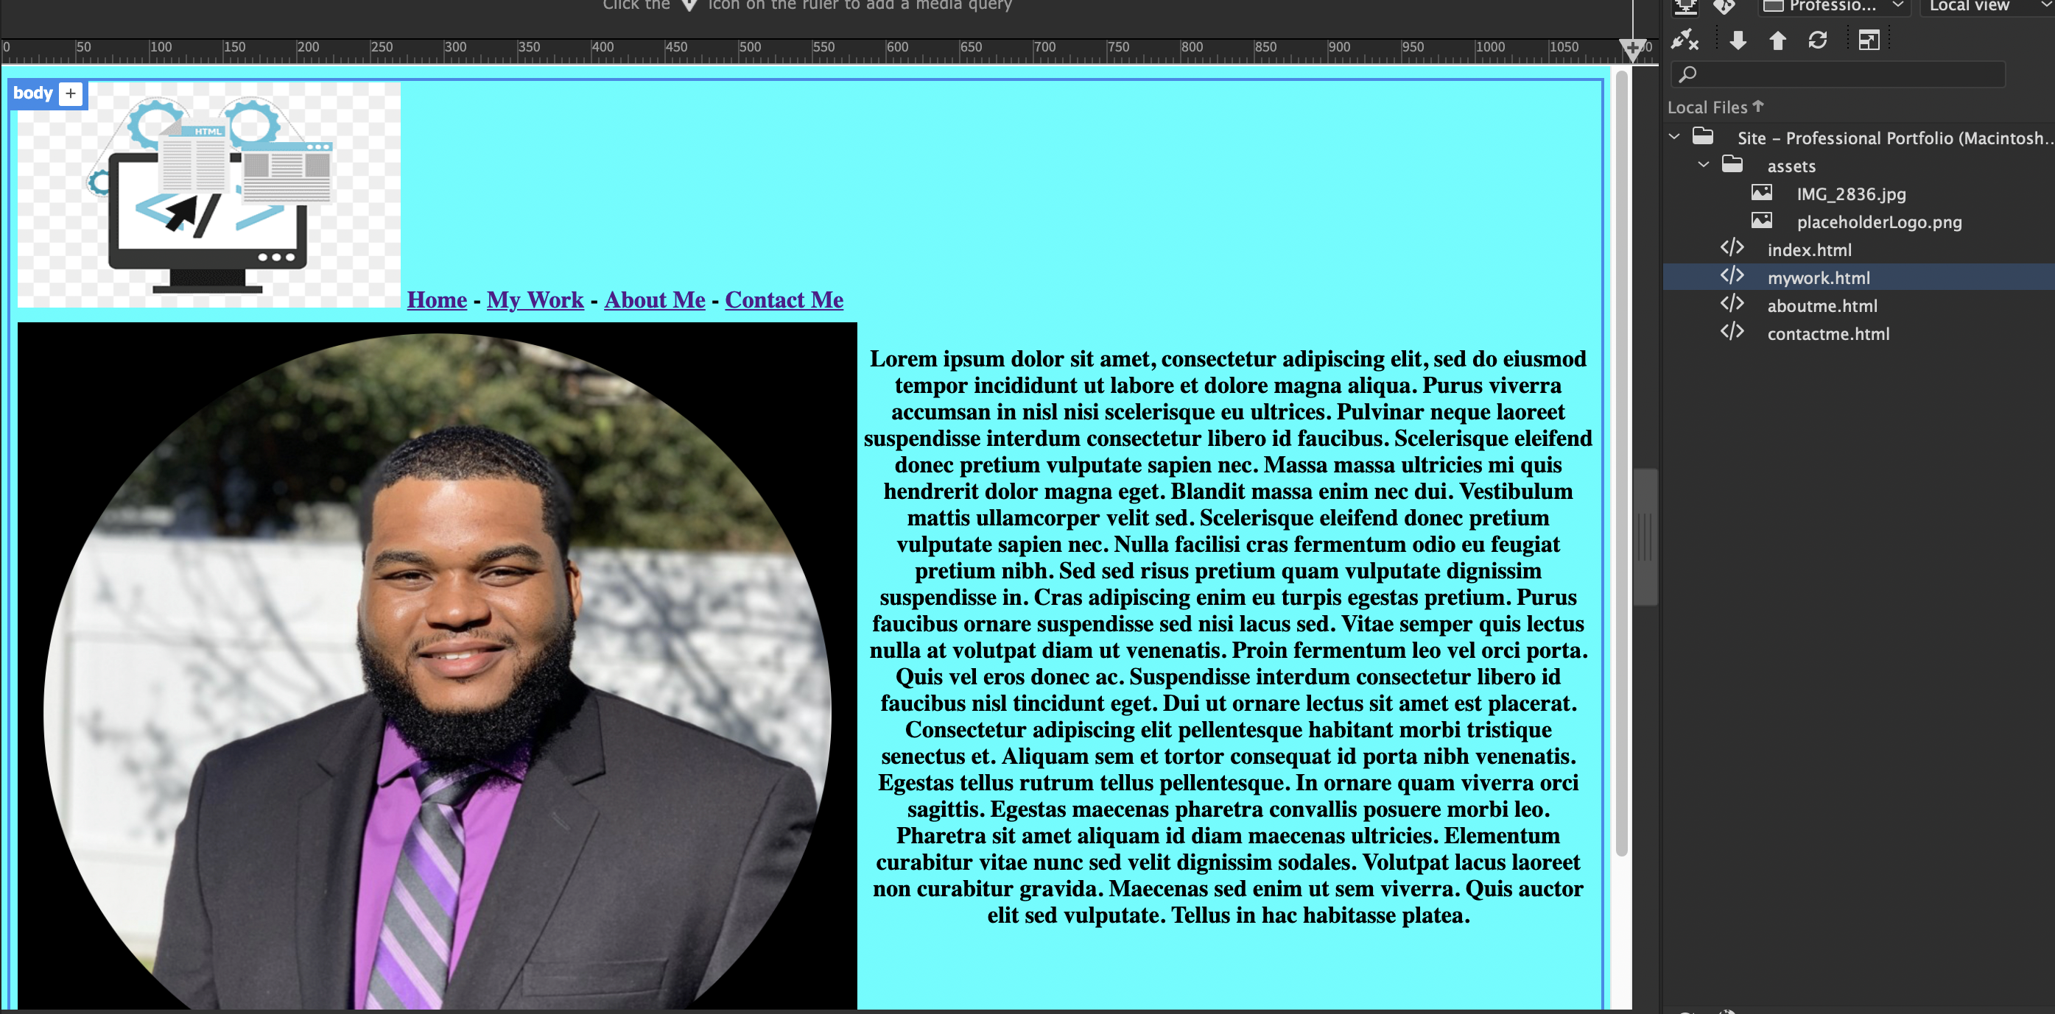

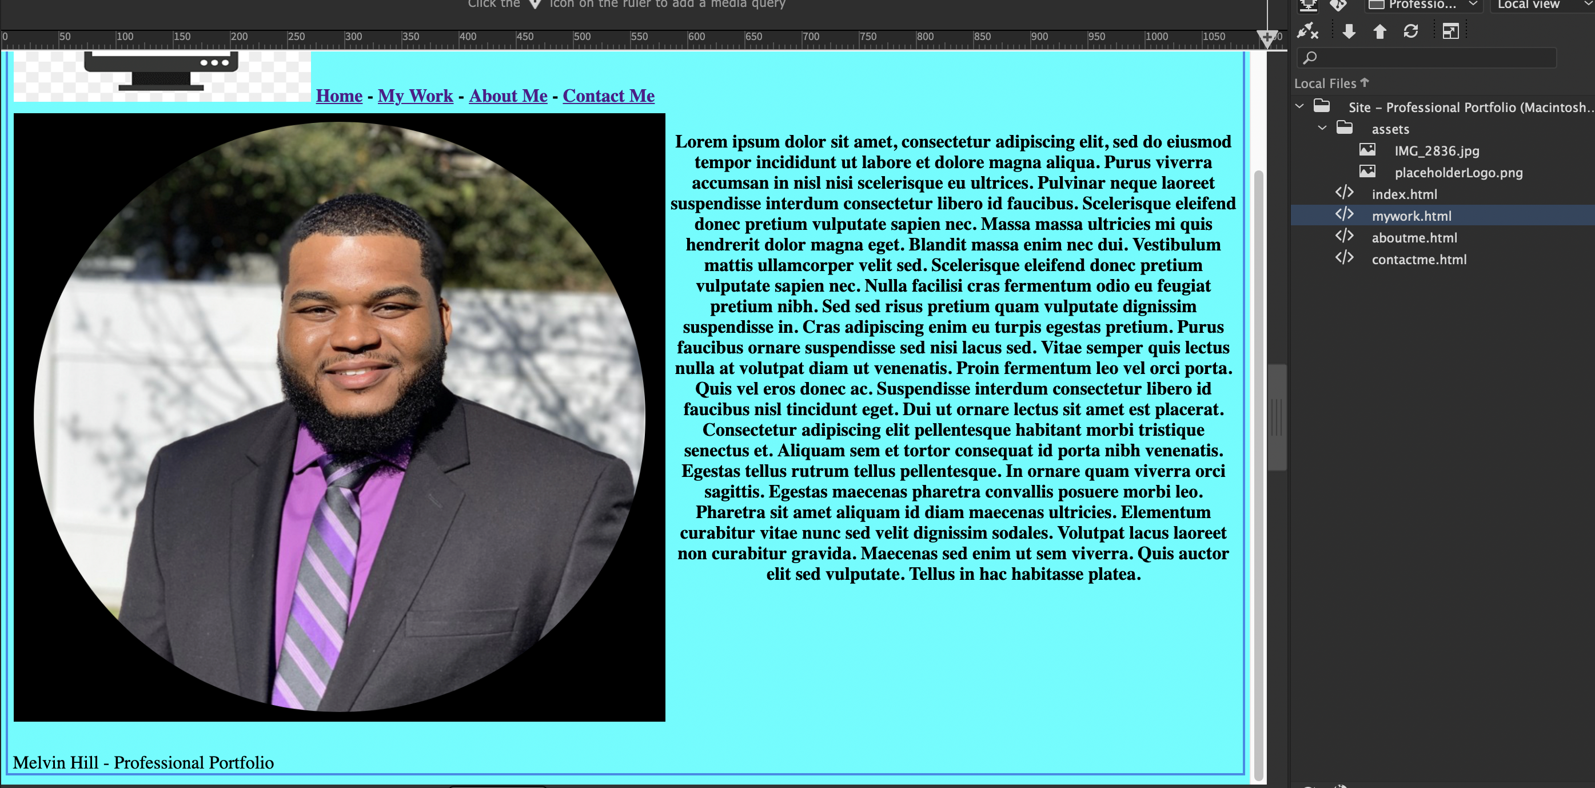

Contact Me Page

